If you have an error on a job => look at the logs generated by the spark executed. (

Note: if you submit a job by connecting directly to the primary node using ssh, you won’t have any logs.

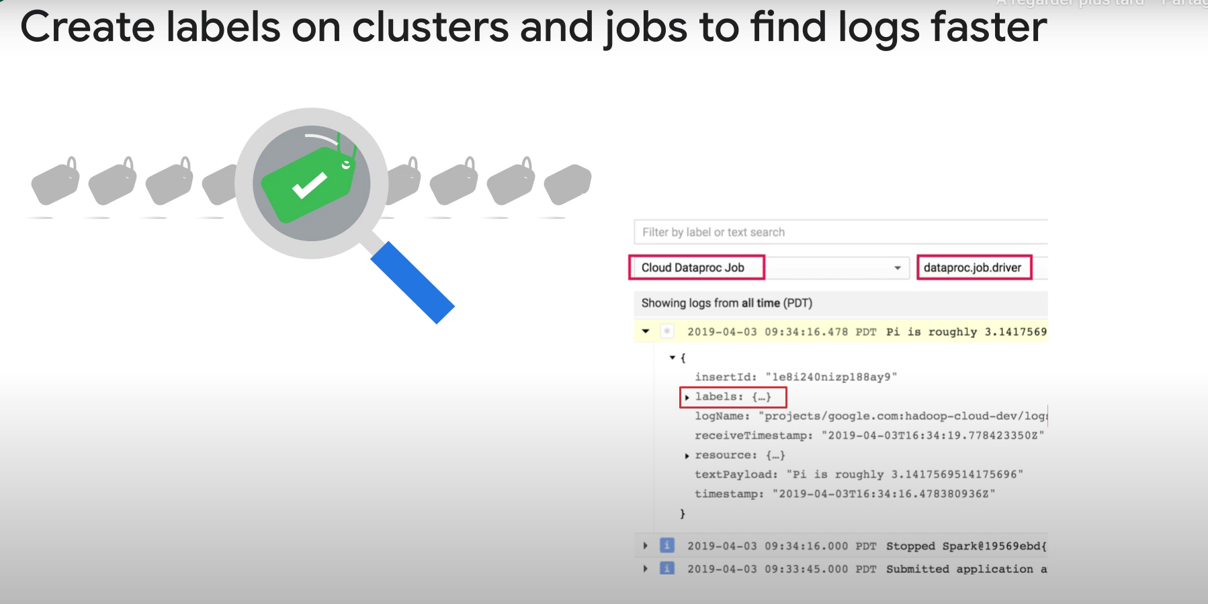

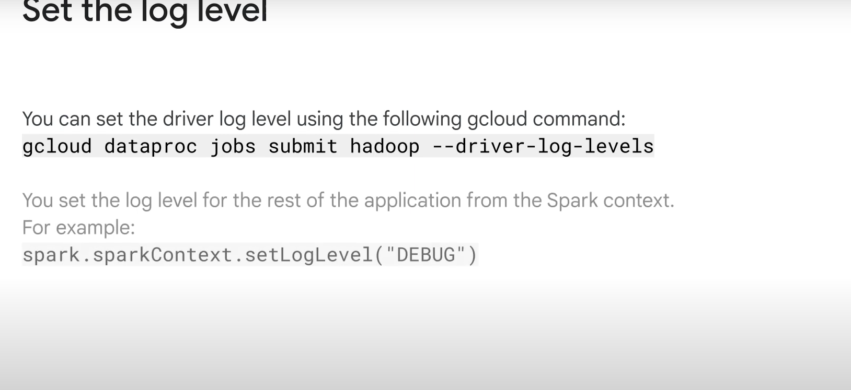

Cloud monitoring can monitor clusteres’ CPU, disk, network usage, and yarn ressources. You can create custom dashboards.